Twitter Notes

Install Lombok via https://www.baeldung.com/lombok-ide

In command window type

C:\_app\Lombok>java -jar lombok-1.18.12.jar

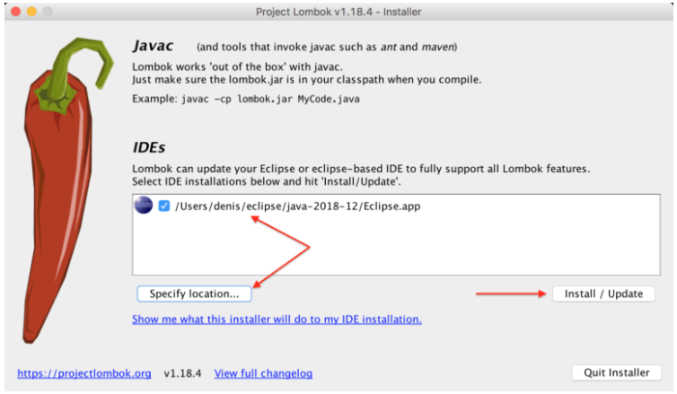

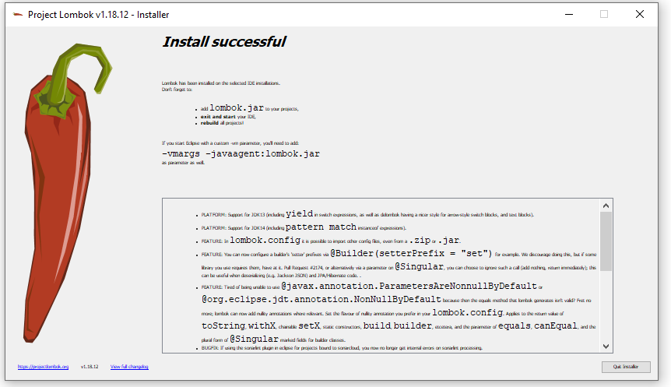

Create Spring Boot Starter project with following addons

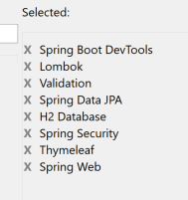

Add this to POM.XML

<dependency>

<groupId>org.thymeleaf.extras</groupId>

<artifactId>thymeleaf-extras-springsecurity4</artifactId>

<version>3.0.2.RELEASE</version>

</dependency>

<dependency>

<groupId>org.ocpsoft.prettytime</groupId>

<artifactId>prettytime</artifactId>

<version>4.0.1.Final</version>

</dependency>